**Software Requirements Specifications (SRS)**

**ERP Solution for Lakhsma Sweater Ltd.**

REFERENCE: GW/ERP/SRS/

**Version: 1.0**

**Date of Release: June 19, 2016**



**Genweb2 Limited**

TK Bhaban (11th Floor),

13 Kazi Nazrul Islam Avenue,

Kawran Bazar, Dhaka 1215, Bangladesh

web: [http://www.genweb2.com](http://www.genweb2.com/)

**Contents**

Document Release History 4

1.0 Introduction 5

1.1 Purpose of SRS 5

2.0 Production Control 6

2.1 Overview 6

2.2 Functional features of Production Control modules are given below (actor wise) 6

2.3 Production Planning Process flow 7

2.4 User Class 8

3.0 Production Control Process Flow: 9

3.1 Production Control Process details: 9

4.0 USE CASE Diagram 11

4.1 Production SAM Declaration Process 11

4.2 Production Rate Declaration Process: 11

4.3 Production Data Update Process: 11

4.4 Employees Production Earnings Generation Process: 12

5.0 USE CASE Details 13

5.1 UC/PP/001/Declare Style & PO wise SAM: 13

5.2 UC/PP/002/Declare Style & PO wise Production Rate: 13

5.3 UC/PP/003/Update Production Data: 14

5.4 UC/PP/004/ Generate Employees Production Earnings: 15

6.0 Production Control mock-up 17

6.1 Production Control master user interface mock-up 17

6.1.1 Production Process: 17

6.1.2 Gauge Wise Machine Block: 18

6.1.3 Organizational General Calendar: 19

6.1.4 Machine Block Wise Calendar: 20

6.2 Production Planning Operational user interface mock-up 21

6.2.1 Style Study 21

6.2.2 Production Data Capture 22

Document Release History

| Sl. No. | Version Number | Release Date | Prepared By | Reviewed By | Approved By | Reasons for New Release |
| --- | --- | --- | --- | --- | --- | --- |
| 1 | 1.0 | 19 June, 2016 | Md. Assalatuzzaman |  | N/A |  |

# Introduction

## Purpose of SRS

The purposes of this SRS are to clearly identify the customer requirements and provide a detailed document. The customer will review the document and approve/make change as required. It will also help the review team to be able to validate whether the customer requirements has been fulfilled.

The SRS will also help the Analyst and Designer to understand and track the Requirements for the proposed system. It will also identify a set of requirements for the Development of the project. The SRS helps to describe the behavior of the system to be developed.

# Production Control

## Overview

Production Control is basically for Production floor control & Production Update. This Module is handling the Actual Production Update for each & every process for any certain Style & Export PO and the Employees Production earnings. This module is also linked up with Production Planning so Production Updated qty will be reduced from the Planned Qty.

## Functional features of Production Control modules are given below (actor wise)

* Real Time Production Data Capture
* Actual Production Data Capture
* Employee Based Production Data Capture
* Shift & Hour Based Production Data Capture
* Real time synchronization with Production Planning Module
* Automated Employees Production Earnings Calculation

## Production Planning Process flow

Production planning process flow consists:

* Defining Production Process
* Create Gauge wise machine Block
* Organizational General calendar Preparation
* Machine Block wise Calendar Preparation
* Style Study
* SAM Declaration
* Production Rate Declaration
* Production Data Capture
* Employees Production Earnings Calculation

## User Class

| **User Class / Actor** | **Characteristics** | **Responsibilities** |
| --- | --- | --- |
| Production Manager | * Add, modify Knitting Machine Block * Add, modify Organizational Calendar * Add, modify Knitting Machine Block Wise Calendar * Add, Modify SAM in Style Study * Add, Modify Rate in Style Study | * Add, modify documents * Maintain other documents related information |
| Production Executive | * Production Data Capture * Calculate Employees Production Earnings | * Add, modify documents * Maintain other documents related information |
| Super admin | * Can do any jobs in system | * Add, modify and delete all information. * Give permission to all users and documents. * Manage the user authentication layer. * Create & assign role to users. * Manage application security. * Manage application settings. |

# Production Control Process Flow:

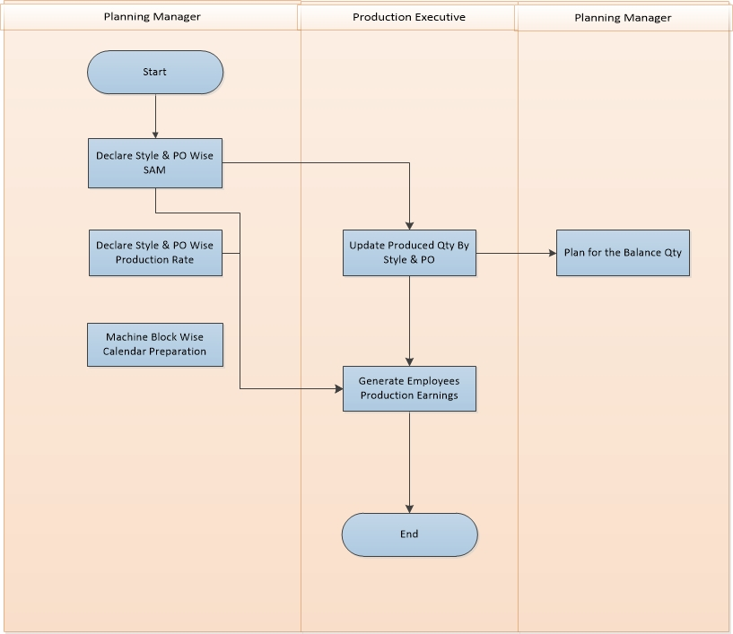

Fig: Production Planning Process

## Production Control Process details:

**Configuration:**

**Production Process:** All Processes and Sub Processes will be declared here in this Production Process Interface, and those will be used in Style Study as require for any certain style.

**Line/Block:** Block or line will have number of same gauge machine for Knitting

**General Calendar:** this is the standard organizational calendar for working hour, working days, Weekend etc.

**Line/Block wise Calendar:** This is line/block specific calendar for working hour, working days, Weekend etc.

**Declare SAM:** Production Manager Declare the SAM (Standard Allowed Minute) for every Style & PO. So it will be set as Standard allowed time for declaring Production Rate.

**Declare Production Rate:** Production Manager Declare the production rate for every Style & Export PO considering the SAM. This Rate will be applied for the earnings of the Piece rated Employee.

**Production Data Update:**

Production Floor Executive Capture the Production data By Style, Export PO, Employee Name for Each process and Sub Process exists for that Style declared in the Style Study. This Process also consider the Date, Shift, Production Hour, Machine No and Produced Qty. So it is basically where Production Floor Executive Capture the Production Data in Details.

**Generate Employees Production Earnings By Style & EPO:**

This is a System intelligence to generate Employees Production Earnings. Based on the Production Rate Declaration by Style & Export PO and Produced Qty by Employee including Shift and Production hour. System Generate the Production Earnings By Employee and make the data available to payroll authority for further payroll process.

# USE CASE Diagram

## Production SAM Declaration Process

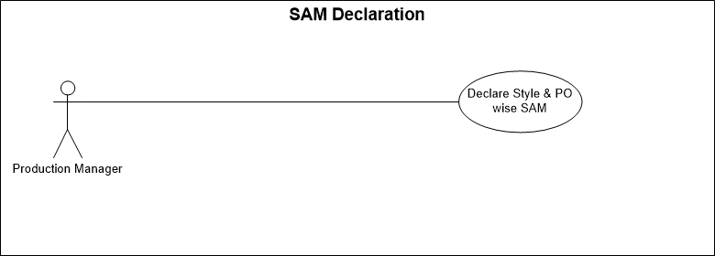

Fig: SAM Declaration Process By Style & Export PO

## Production Rate Declaration Process:

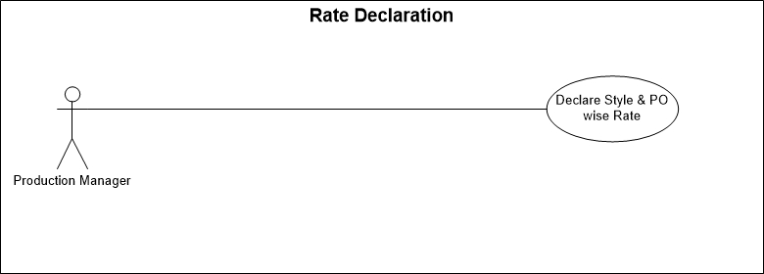

Fig: Rate Declaration Process By Style & Export PO

## Production Data Update Process:

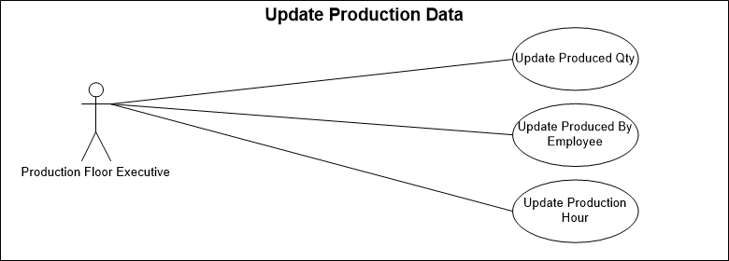

Fig: Production Data Update Process

## Employees Production Earnings Generation Process:

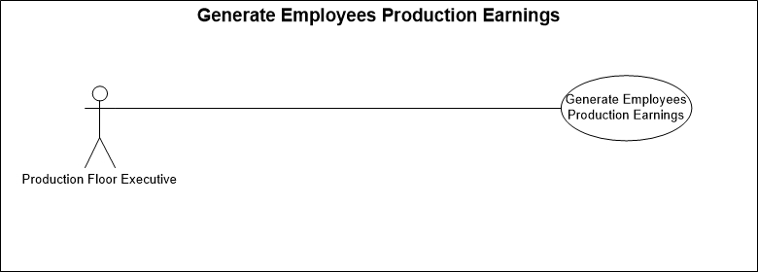

Fig: Employees Production Earnings Generation Process

# USE CASE Details

## UC/PP/001/Declare Style & PO wise SAM:

|  |  |  |
| --- | --- | --- |
| Use Case ID: UC/PC/001 | | |
| Use Case Name**: Declare Style & PO wise SAM** | | |
| Created By: **GenWeb2 Ltd.** | | Date Created: 12 June, 2016 |
| Actors: | * Production Manager | |
| Trigger: | When Production Manager Declare the SAM (Standard Allowed Minutes) of Style & Export PO. | |
| Business Rule | * Production Manager will declare the SAM for the Style & Export PO in Style Study. | |
| Description: | SAM will be declared for each & every Process & Sub Process. | |
| Frequency of Use | * Medium | |
| Preconditions | * N/A | |
| Post conditions | * Appropriate message will be displayed after each entry being saved / updated. * SAM will be saved in Style Study | |
| Assumption | Organization already in Practice of SAM | |
| Goal | To record SAM for Style & Export PO in System | |
| Normal Flow | Production Manager declare the SAM in Style Study for every Process & Sub Process | |
| Alternate Flow | * N/A | |
| Exception | * Proper message should be displayed if SAM can’t be saved. * Proper message should be displayed if any master or dependent data is missing or not found. * Appropriate message should be displayed if mandatory fields are not filled. * Any system exception/Application exception should be handled centrally with proper user message during the page browse/save/update/view operations. | |
| Cross Reference | * N/A | |

## UC/PP/002/Declare Style & PO wise Production Rate:

|  |  |  |
| --- | --- | --- |
| Use Case ID: UC/PP/002 | | |
| Use Case Name**: Declare Style & PO wise Production Rate** | | |
| Created By: **GenWeb2 Ltd.** | | Date Created: 12 June, 2016 |
| Actors: | * Production Manager | |
| Trigger: | When Production Manager Declare the Production Rate for every Process & Sub Process of any Style & Export PO. | |
| Business Rule | * Production Manager will declare the Rate for every Process & Sub Process of the Style & Export PO in Style Study. | |
| Description: | Production Rate will be declared for each & every Process & Sub Process of that Style & Export PO. | |
| Frequency of Use | * Medium | |
| Preconditions | * N/A | |
| Post conditions | * Appropriate message will be displayed after each entry being saved / updated. * Production rate will be saved in Style Study | |
| Assumption | Organization already in Practice of Production rate | |
| Goal | To record Production rate for Style & Export PO in System | |
| Normal Flow | Production Manager declare the Production rate in Style Study for every Process & Sub Process of that Style & Export PO | |
| Alternate Flow | * N/A | |
| Exception | * Proper message should be displayed if Production Rate can’t be saved. * Proper message should be displayed if any master or dependent data is missing or not found. * Appropriate message should be displayed if mandatory fields are not filled. * Any system exception/Application exception should be handled centrally with proper user message during the page browse/save/update/view operations. | |
| Cross Reference | * N/A | |

## UC/PP/003/Update Production Data:

|  |  |
| --- | --- |
| Use Case ID: UC/PP/003 | |
| Use Case Name**: Update Production Data** | |
| Created By: **GenWeb2 Ltd.** | Date Created: 12 June, 2016 |
| Actors: | * Production Floor Executive |
| Trigger: | When Production Executive Update the Production Data. |
| Business Rule | * Production Manager Declare Production Rate * Production Executive Capture Production Data |
| Description: | Production Executive Capture the Production Data in details by Process, Sub Process, Date, Shift, Hour, Employee, Style, EPO, Machine No and Produced Quantity. |
| Frequency of Use | Medium |
| Preconditions | * N/A |
| Post Conditions | * Appropriate message will be displayed after each entry being saved / updated. * Production Data will be saved in System. * Produced Qty will be reduced from the planned Qty in Production Planning |
| Assumption | Organization already in practice of Production Data Capture |
| Goal | Capture Production Data in System. |
| Normal Flow | * Production Executive will capture the Actual Production Data. |
| Alternate Flow | N/A |
| Exception | * Proper message should be displayed if Production Data Capture can’t be saved. * Proper message should be displayed if any master or dependent data is missing or not found. * Appropriate message should be displayed if mandatory fields are not filled. * Any system exception/Application exception should be handled centrally with proper user message during the page browse/save/update/view operations. |
| Cross Reference | * N/A |

## UC/PP/004/ Generate Employees Production Earnings:

|  |  |  |
| --- | --- | --- |
| Use Case ID: UC/PP/004 | | |
| Use Case Name**: Generate Employees Production Earnings** | | |
| Created By: **GenWeb2 Ltd.** | | Date Created: **12 June 2016** |
| Actors: | Production Floor Executive | |
| Trigger: | When Production Executive Generate Employees Production Earnings | |
| Business Rule | * Production Manager Declare the Production Rate of every Process & Sub Process for any Style & Export PO. * Production Executive Capture the Production data * Production Executive Generate the Employees Production Earnings | |
| Description: | Production Executive Generate the Employees Production Earnings by Capturing the Production data in details and Production Rate declared by the Production Manager for every process & Sub process of the Style & PO | |
| Frequency of Use | Medium | |
| Preconditions | * N/A | |
| Post conditions | * Appropriate message will be displayed after each entry being saved / updated. * Employees Production Earning will be saved in System * Employees Production Earnings will be available to Payroll authority for further action | |
| Assumption | N/A | |
| Goal | * To generate Employees Production Earnings | |
| Normal Flow | * Production Manager Declare Production Process & Sub Process wise rate for any Style & Export PO * Production Executive Capture Actual Production Data (Employee Name, Date, Production hour, Shift Etc.) * Production Executive Generate Employees Earnings based on declared Rate & Actual Production By Employee. | |
| Alternate Flow | * N/A | |
| Exception | * Proper message should be displayed if Employees Production Earnings can’t be saved. * Proper message should be displayed if any master or dependent data is missing or not found. * Appropriate message should be displayed if mandatory fields are not filled. * Any system exception/Application exception should be handled centrally with proper user message during the page browse/save/update/view operations. | |
| Cross Reference | * N/A | |

# Production Control mock-up

## Production Control master user interface mock-up

### Production Process:

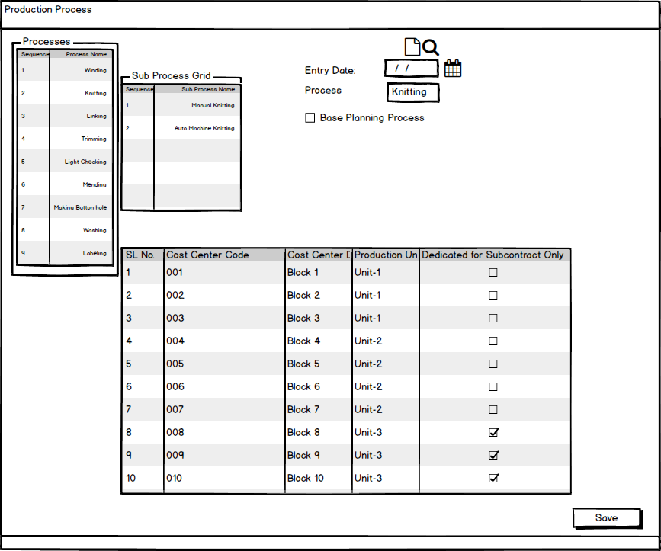

Fig: Production Process

### Gauge Wise Machine Block:

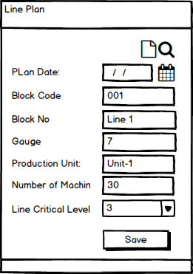

Fig: Gauge wise machine block

### Organizational General Calendar:

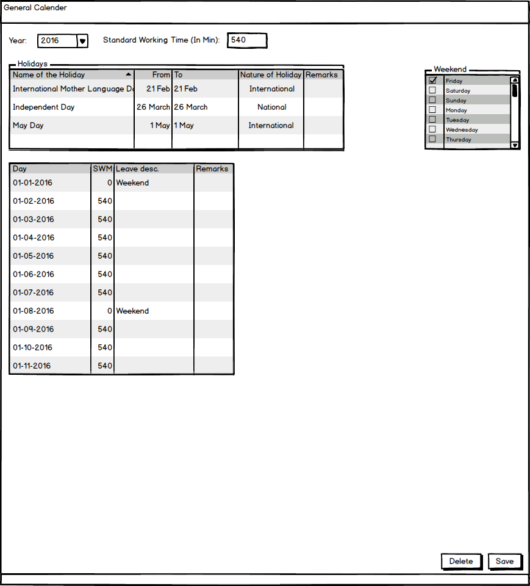

Fig: Organizational General Calendar

### Machine Block Wise Calendar:

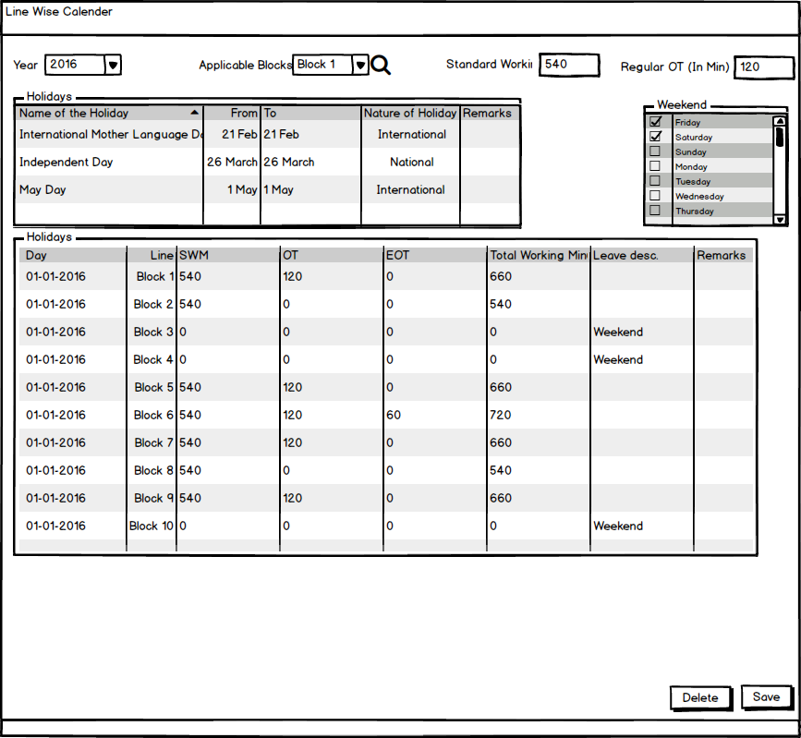

Fig: Machine Block Wise Calendar

## Production Planning Operational user interface mock-up

### Style Study

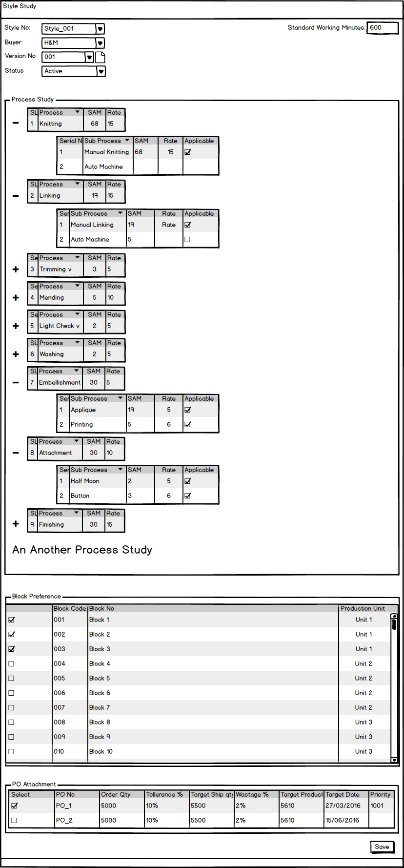

Fig: Style Study

### Production Data Capture

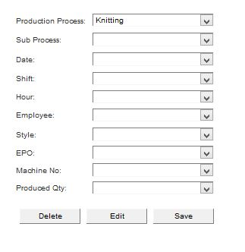

Fig: Production Data Capture